  
  
  
  
  
Yotam Gilad: 315819599  
Gad Azriel: 209146927  
Tomer Ben-Lulu: 318318987  
Almog Elbaz: 213037369

Direct link to the website: <https://cook-mate-kappa.vercel.app>  
Link to the repository: <https://github.com/GadAzriel/CookMate>  
Link to MTW: <https://www.morethanwallet.com/app/862>

**CookMate** is an interactive cooking website that makes cooking fun. It offers a variety of recipes with detailed ingredients and preparation steps. Users can adjust serving sizes, and the ingredient amounts will be updated accordingly. CookMate also features a step-by-step guide with a timer, progress bar, and voice assistance. The site is responsive, ensuring a seamless experience across all devices, with intuitive navigation for easy recipe browsing.

**Key Features**

* Recipe Exploration: Users can easily browse a curated selection of recipes directly from the homepage, with a carousel feature to showcase various dishes and inspire their next meal.
* In-Depth Instructions: Each recipe provides detailed preparation steps and a comprehensive list of ingredients to ensure successful cooking.
* Interactive Cooking Guide: The step-by-step feature guides users through the cooking process with visual progress indicators, timers, and voice command support.
* Responsive Design: The user interface is optimized for various screen sizes, delivering a seamless experience across desktops, tablets, and mobile devices.
* Accessibility: Navigation controls and UI elements are designed for easy use, ensuring accessibility for all users.

**Technologies Used**

* React: Utilized for building the user interface with a component-based architecture, making the application modular and maintainable.
* Tailwind CSS: A utility-first CSS framework used for efficient and responsive styling directly within the JSX code.
* React Router: Enables seamless navigation between different components and pages within the application.
* JSON Database: All recipe data is stored and retrieved from a JSON file, acting as a lightweight and easy-to-manage database.

|  |  |  |
| --- | --- | --- |
| **שם חבר צוות** | **משימות שהוקצו** | **משימות שהושלמו** |
| גד אזריאל | 1. עדכון ארכיטקטורה של האתר. 2. החלפה לreact ועבודה על האתר. 3. חלוקת עבודה. 4. הוספת dark-mode לאתר. | כלל המשימות מולאו. |
| אלמוג אלבז | 1. עדכון ארכיטקטורה של האתר. 2. עבודה על האתר שימוש ב-React 3. בניית ה- DB (קובץ ה- Json של המתכונים) | כלל המשימות מולאו. |
| יותם גלעד | 1. עבודה על האתר שימוש ב-React 2. תיק מתכנת. 3. בניית תרשימים למשימה. | כלל המשימות מולאו. |
| תומר בן-לולו | 1. עבודה על האתר שימוש ב-React 2. עדכון והוספת דרישות. 3. תיק משתמש. | כלל המשימות מולאו. |

**Assignments**

תחתית הטופס

**Requirements**

|  |
| --- |
| **FR** |
| The system will enable users to select a recipe from a list of available options. |
| The system will allow users to view detailed instructions and information for each recipe. |
| The system will include an interactive cooking assistant named "Interactive assistance." |
| The system will feature a Manual mode for user control. |
| The system will offer an Automatic mode for guided cooking. |
| The system will include a progress bar to display cooking progress. |
| The system will allow users to control and adjust the timer. |
| The system will enable users to modify recipe quantities. |
| The system will include voice command for recipes steps. |

|  |  |
| --- | --- |
| **NFR** | |
| **Requirement** | **Type** |
| The website shall be user-friendly, with intuitive navigation and a responsive design suitable for various devices (desktop, tablet, smartphone). | Usability |
| The website will provide images for recipes, interactive assistant (step), and cooking progress, along with voice assistance. | Usability |
| The website will load within 3 seconds on standard broadband connections, and recipe steps will advance smoothly in "Automatic Mode" without any lag. | Performance |
| The system will accommodate an increasing number of users and recipes without compromising performance or usability. | Scalability |
| The website will be available 24/7 | Availability |
| The website will offer customization options for users, such as theme selection, layout preferences, and notification settings, to enhance the personal user experience. | Customization |
| Recipe quantities will be adjusted based on the number of servings the user chooses. | Customization |
| Manual mode, Automatic mode, Progress bar, timer, timer controllers, recipe adjustments, voice assistance – will all be a part of the "Interactive assistant" feature. | Structure |
| The dark mode will be changeable by clicking. | Emotional Factors. |

**Use Case**

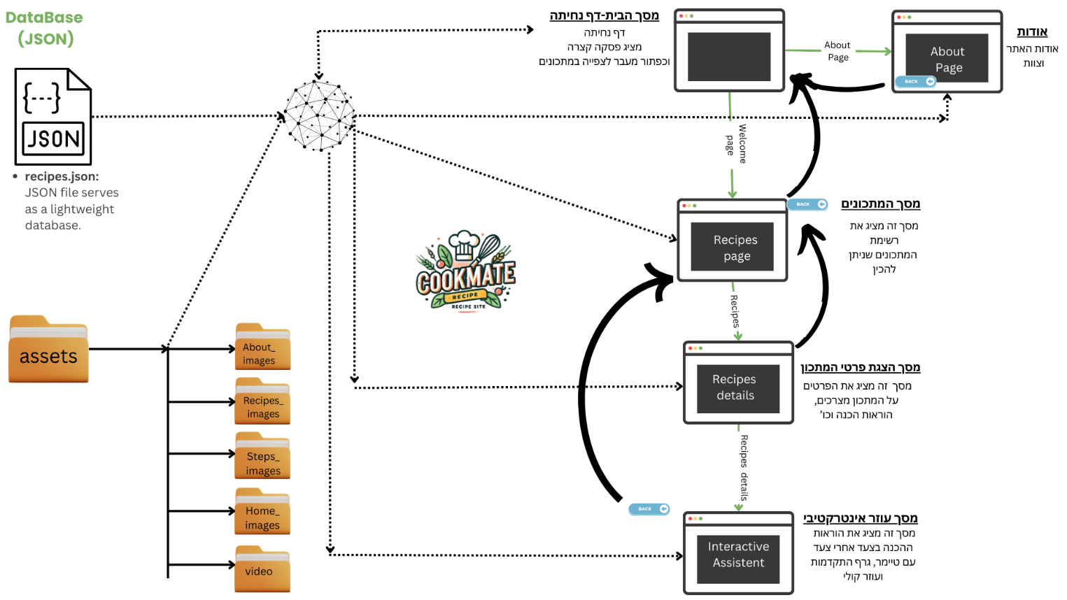**Architecture**

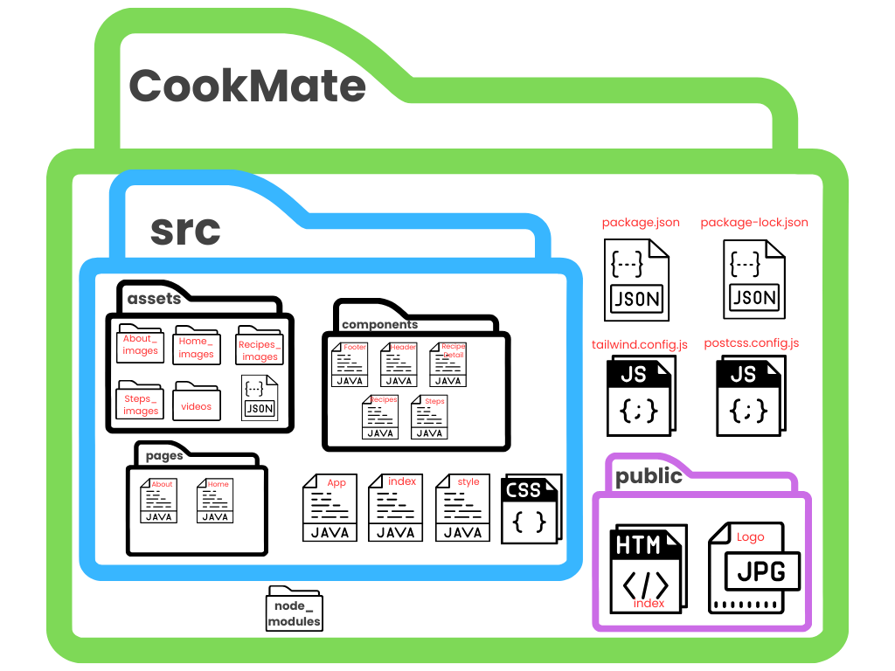**File and folder diagram**

**Project Structure Diagram**

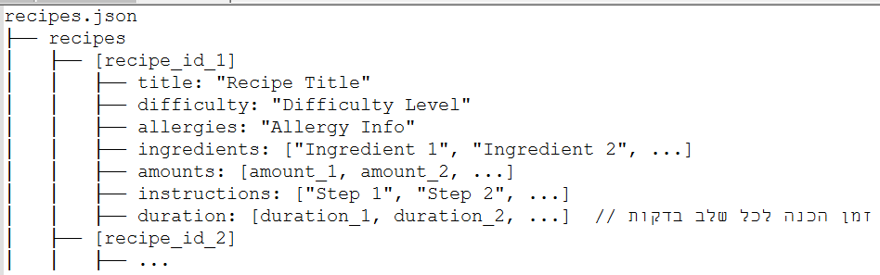**Database Structure**

Explanation:

* **recipes**: An array containing all the recipes in the project. Each recipe is an object with a unique identifier.
* **title**: The name of the recipe.
* **difficulty**: The difficulty level of the recipe (e.g., Easy, Medium, Advanced).
* **allergies:** Information related to any allergies associated with the recipe (if applicable).
* **ingredients**: An array of ingredients required to prepare the recipe.
* **amounts**: The quantity of each corresponding ingredient.
* **instructions**: An array of preparation instructions, where each item represents a step.
* **duration**: An array of time durations, where each value corresponds to the preparation time for each step in minutes.